**DOM Elements**

In JavaScript, DOM (Document Object Model) elements represent the various components of an HTML or XML document. These elements can be accessed, manipulated, and updated dynamically using JavaScript.

To access DOM elements in JavaScript, you can use various methods such as getElementById(), getElementsByClassName(), getElementsByTagName(), querySelector(), and querySelectorAll(). These methods allow you to select specific elements from the DOM based on their ID, class, tag name, or other attributes.

Once you have selected a DOM element, you can manipulate it using various properties and methods. For example, you can change the content of an element using the innerHTML property, or change its style using the style property. You can also add or remove classes using the classList property, or add event listeners using the addEventListener() method.

Here's an example of accessing a DOM element with the getElementById() method and changing its content:

**<!DOCTYPE html>**

**<html>**

**<head>**

**<title>DOM Elements Example</title>**

**</head>**

**<body>**

**<div id="myDiv">This is a div element.</div>**

**<script>**

**// Access the element with the ID "myDiv"**

**var myElement = document.getElementById("myDiv");**

**// Change the content of the element**

**myElement.innerHTML = "This content has been changed!";**

**</script>**

**</body>**

**</html>**

In this example, we first select the element with the ID "myDiv" using getElementById(). We then change the content of the element using the innerHTML property.

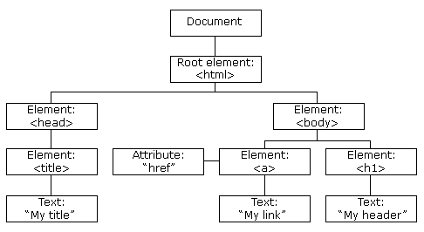

With the object model, JavaScript gets all the power it needs to create dynamic HTML:

* JavaScript can change all the HTML elements in the page
* JavaScript can change all the HTML attributes in the page
* JavaScript can change all the CSS styles in the page
* JavaScript can remove existing HTML elements and attributes
* JavaScript can add new HTML elements and attributes
* JavaScript can react to all existing HTML events in the page
* JavaScript can create new HTML events in the page

## 

## 

## The Browser Object Model (BOM)

There are no official standards for the Browser Object Model (BOM).

Since modern browsers have implemented (almost) the same methods and properties for JavaScript interactivity, it is often referred to, as methods and properties of the BOM.

Browserin melumatlari ile baglidir.

Mes. Window objecti.

## The Window Object

The window object is supported by all browsers. It represents the browser's window.

All global JavaScript objects, functions, and variables automatically become members of the window object.

Global variables are properties of the window object.

Global functions are methods of the window object.

Even the document object (of the HTML DOM) is a property of the window object:

document

is the same as:

getElementById